A000-ME-Syria-Tell Brak-Eye Idol-Globular–Golden Marble-ca 4th Millennium BCE

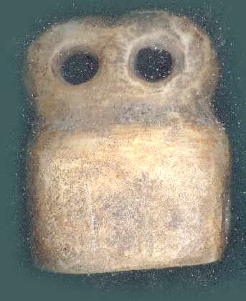

Fig. 2. . Eye-Idol (3500-3300 BCE), Rectangular Base Type, Circular, perforated “Eyes.” Temple of the Eyes, Tell Brak, Syria, alabaster (gypsum). Provenance: Atlantika Collection.

**Case no.: 3**

**Accession Number:**

**Formal Label: Tell Brak, Syria, “Eye Idols**”, 3500-3300 BCE

**Display Description:** Tell Brak (ancient Nagar) was one of the largest cities of the 4th millennium BCE in ne Syria (43 hectares). Eye Idols were designed to portray the resolute eye of Inanna-Ishtar who guarantees a good fate for her faithful. This is the reason why so many hundreds of these personal "eye-idol" amulets were found at Tell Brak that was excavated in the 1930's by Max Mallowan (husband of Agatha Christie), who called the structure in which they were found the “Eye Temple” (Mallowan 1947). The figurines were carved from calcite, alabaster and quartzite as well as being molded from clay.

**LC Classification:** [DS99.B57](http://innovative.pts.edu/search?/cDS99.B57+E92+2003/cds+++99+b57+e92+2003/-3,-1,,E/browse)

**Date or Time Horizon:** 3500-3300 BCE

**Geographical Area:** Tell Brak, Syria

**Map, GPS coordinates: 36.66833 41.05722;** 40° 26' 46" N 79° 58' 56" W

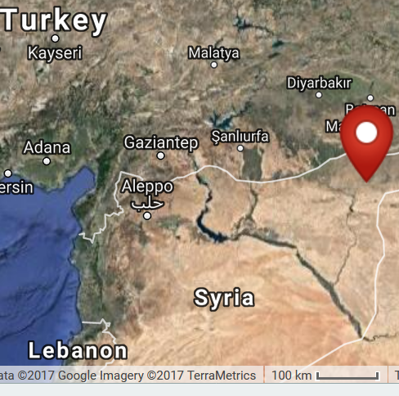

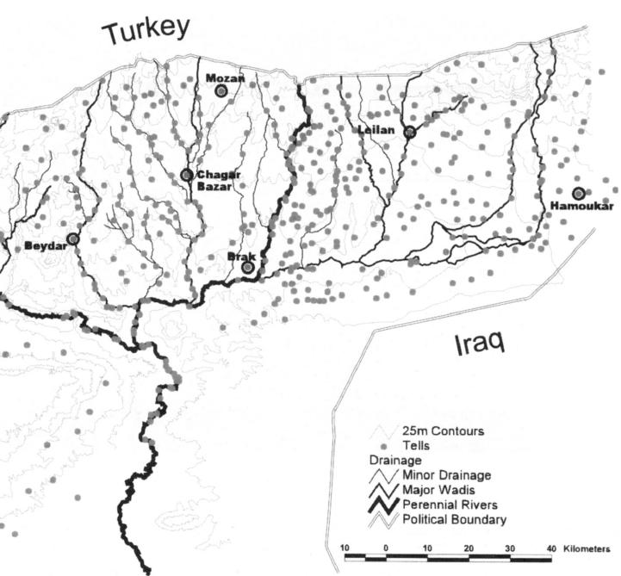

**Cultural Affiliation:** Tel Brak

**Medium:** Alabaster

**Dimensions:**

**Weight: various**

**Condition: Original**

**Provenance:** **Ex. Early European Private Collection, Galeria Archeologia, EEE**

**Discussion:** Because Tell Brak was located in the s margin of the Khabur plains, it controlled a large agricultural zone that provided produce for trade not only with local Ebla 280 km to the w but also with distant Sumeria connected by Euphrates River Trade (Akkermans and Schwartz 2003: 185). This latter connection with Sumerian cities (Ur, Uruk and Lagash) who worshipped Inanna, their most prominent female deity, provides the clue of the meaning of these Eye Idols. Inanna was equated with Tell Brak’s Ishtar (Ištar), and both were characterized as being ever protective and vigilant over their faithful worshippers which is expressed in a Neo-Sumerian hymn:

an-zíb-ba zag ḫi-lian-na me-te-an-daĝal-la

ĝi6-ù-na iti6 gin7 mu-un-è ...

an-bar7-gána ud-zalag-gin7 mun-un-è

...

si-sá-ra igi-zid mu-un-ši-in bar nam-dùg mi-ni-in-tar (Reisman 1969: 155, ll. 110-112, 119).

The skilled and beautiful one [Inanna], the delight of An [her father], the ornament of broad heaven,

[She] Manifests like Moon at night,

[She] Manifests like Sun at midday.

...

She gazes on her faithful with resolute eye. She ordains a good fate for them. (Author’s own translation)

**References:**

Matthews, Donald M. 1997. *The early glyptic of Tell Brak : cylinder seals of third millennium Syria.* Orbis Biblicus et Orientalis, Series archaeologica, 15. Fribourg Switzerland: University Press; Göttingen: Vandenhoeck & Ruprecht.